



**Request for Proposals**

**Digital Fingerprint Collection Services**

**Alabama Real Estate Commission**

TABLE OF CONTENTS

Page

Part 1. Solicitation; Description of Services; Qualifications. ................................................. 3

1.1. Solicitation of proposals. ................................................................................... 3

1.2. Description of Services. ...................................................................................... 3

1.3. Qualifications and Responsibilities. .................................................................. 3

Part 2. Proposal Content. .................................................................................................... 5

2.1. Responsiveness. ............................................................................................... 5

2.2. Unacceptable terms or conditions. .................................................................... 5

2.3. Required content. ............................................................................................. 6

Part 3. Proposal Format. ...................................................................................................... 7

3.1. Legibility and organization. ............................................................................... 7

3.2. Supporting documents and materials. .............................................................. 7

3.3. Claim of protection for proprietary information. ................................................ 7

3.4. Submittal letter. ...............................................................................................7

Part 4. Submission of Proposal. ..........................................................................................8

Part 5. Other Terms. ........................................................................................................... 8

5.1. Anticipated Timetable. ...................................................................................... 8

5.2. Contact Person. ..................................................................................................9

5.3. Questions. ………………………………………….........................................................9

5.4. Evaluation Criteria; Evaluation Committee. .......................................................9

5.5. Contract. ............................................................................................................9

5.6. Rejection of proposals. .......................................................................................9

5.7. Waiver of minor deviations. .................................................................................9

5.8. Public Record. ...................................................................................................9

5.9. Proposal preparation costs. .................................................................................9

5.10 Other Clauses ……………………………………………………………………………………9

Exhibit “A”. Process Flowchart. ........................................................................................... 10

Part 1. Solicitation; Description of Services; Qualifications.

1.1. Solicitation of proposals. The Alabama Real Estate Commission, hereafter referred to as the Commission, a department of the state government of Alabama, solicits proposals from qualified Suppliers to enter into a contract with the Commission to furnish the Services described in this Request for Proposal (RFP). The Alabama Real Estate Commission will recommend the award to the CPO (Chief Procurement Officer), and the Division of Procurement issues the intent to award. The contract resulting from this RFP will commence upon receiving all requisite state government approvals and will end October 31, 2027. The Commission shall have the right, at its sole option, to renew the contract for one (1) additional two-year period and then one (1) additional one-year period. In the event the Commission exercises such right, all terms, conditions, and provisions of the contract shall remain the same and apply during the renewal period, pursuant to the application of option clauses of this document. The Commission is not committed to entering into any contract as a result of this RFP.

1.2. Description of Services. The following Services shall be provided under a contract awarded as a result of this RFP on an as-requested or as-needed basis:

1.2.1. On behalf of and as directed by the Commission, the supplier will provide digital fingerprint collection services for individuals seeking a real estate license by the Commission.

1.2.2. The supplier will work with individuals applying for license by the Commission requiring a criminal history background investigation (applicants) to secure payment of fees, digitally collect fingerprints, transmit them electronically, and transmit electronic Criminal History Record Information regarding applicants to the Commission.

1.3. Qualifications and Responsibilities. The supplier should be an experienced digital fingerprint collection service and able to provide high-quality digital fingerprint collection services for individuals who are seeking to be licensed by the Commission and require a criminal history background investigation (applicants).

1.3.1. Estimated current Commission licensing volume is approximately 3,000 individuals per year. The approximate numbers for the past three years are indicated below:

|  |  |  |  |
| --- | --- | --- | --- |
| YEAR | 2022 | 2023 | 2024 |
| # PRINTED | 4101 | 4127 | 3569 |

1.3.2. The Commission does not require exclusivity. The supplier may offer these services to other agencies so long as this neither negatively impacts service nor compromises the security of the fingerprints and personal data of applicants.

1.3.3. The Commission does not wish to own or operate the equipment required to perform these services. Fingerprint collection sites are to be selected and equipped, and staff trained by the supplier. These sites must be readily accessible to the public and located in areas that minimize any physical threat to the person who is to be fingerprinted. It is highly desirable that the sites be available on an extended-hours basis. Mobile service should be available to accommodate special circumstances.

1.3.4. Finger and thumb palm prints to include a “four fingers taken simultaneously” print for each hand as directed by the Applicant Fingerprint card (FD-258) acceptable to the Alabama Law Enforcement Agency (ALEA) and the Federal Bureau of Investigation (FBI), are to be captured through livescan equipment that meets all ALEA and FBI standards and requirements. To insure compliance with technical and security requirements, the Commission prefers that the supplier be certified as a channeler by the FBI. The supplier must be able to accept and process rolled prints from cards to accommodate instances in which the applicant cannot go to an authorized scan site. However, it is preferable that a supplier’s sites in other states be available to Alabama applicants rather than requiring all out-of-state applicants to submit rolled cards.

1.3.5. Currently, the charge for a fingerprint-based criminal history background check is $45.95. ALEA invoices the supplier $37.00 per check. If the charges for the criminal history background check change during the time of the contract, the fee charged for fingerprint collection should also reflect the change in price. Fees required by ALEA and FBI for fingerprint processing along with any transaction-based fees are to be collected from the applicant by the supplier. Notice of any fee increase must be reported to the Real Estate Commission, in writing, at least 30 days prior to becoming effective and collected from applicants. Fees charged by ALEA and FBI must be paid to ALEA by the supplier within 30 days or earlier if possible. ALEA will be responsible for paying the FBI fees to the FBI.

1.3.6. Individual applicants should be able to pay for the service at the time of fingerprint collection. Services may be provided by the supplier to other state agencies so long as the fee processing is separate from that of the Commission.

1.3.7. Prints, accompanying data, and release documentation are to be transmitted in a secure manner to ALEA to be processed through the ALEA and FBI AFIS systems. ALEA will submit prints to the FBI. Reports of clear records and criminal history background reports must be returned to the Commission in a secure electronic fashion compatible with the Commission’s secure system and consistent with the security requirements established under state and federal law and regulations or rules.

1.3.8. Scan sites are to be established by the supplier to serve applicants within the state of Alabama. Scan sites must be situated so that approximately 95% of applicants reside within 20 miles of a scan site.

1.3.9. Scan sites must be safe, secure, accessible, and have adequate parking. Hours of operation must be at a minimum 8:00 AM to 5:00 PM, Monday through Friday, with extended and weekend hours highly desirable. The locations must be Americans with Disabilities Act compliant.

1.3.10. Supplier must allow applicants to schedule appointments for fingerprinting via telephone or internet. Appointments generally will not be required.

1.3.11. Supplier must be able to provide mobile scanning services to accommodate extraordinary circumstances such as accommodating applicants under ADA and as a response to natural disasters.

1.3.12. Supplier must have substantial experience in providing fingerprint services through a network of scanning sites. Supplier is requested to provide the locations of all scanning sites it offers in the United States. Supplier must be able to provide references from public entities for which it currently provides similar services.

1.3.13. Supplier must be bonded and insured and provide evidence of sound financial standing, including balance sheets and income statements.

1.3.14. Supplier must be able to securely process fee payments by credit or debit card, money order, check, cash, or direct agency billing.

1.3.15. Supplier must be able to accommodate multiple agency accounts with separate account settlement with each agency.

1.3.16. Supplier must be able to provide activity tracking and transaction reports as required by the Commission and must also provide a means for electronic retrieval of data files to and from the Commission.

1.3.17. Supplier must be able to process fingerprint submission in real time with a legibility and acceptability rate of at least 97%. Backgrounds to be available to the Commission within 48 hours of scanning 97% of the time.

1.3.18. Supplier and its employees must ensure that applicants present proper identification at the time of fingerprinting.

1.3.19. Supplier and its employees must comply with all federal and state laws, regulations, and standards (including CJIS Security Policy) as well as with rules, procedures, and standards established by the Compact Council and United States Attorney General.

1.3.20. Supplier must meet all requirements of the CJIS Security Policy, ALEA and FBI

standards and requirements for livescan.

1.3.21. Supplier must comply with the data encryption mandates required by FBI CJIS.

1.3.22. Supplier must be certified by the FBI as channelers.

1.3.23. Supplier must meet the Commission’s security requirements and have an established protocol to insure that applicants’ personal data and images are secure and are not retained on livescan machines beyond the time required to complete the fingerprint scanning, transmission, and validation process.

1.3.24. Supplier must provide to the Commission advance notice of at least 180 days prior to termination of the contract for any reason.

1.3.25. Supplier must provide both telephone and e-mail helpline services as a means of resolving transmission issues and other problems that should occur.

1.3.26. Supplier must provide an initial response to a request for help sent to the helpline services within 48 hours of the receipt of such a request.

1.3.27. Supplier must have fingerprint sites operational and staffed appropriately no later than the start of the agreed upon contract date. This is expected to be on or around November 1, 2025.

1.3.28. Supplier must establish and make fully operational a Web site that provides information about the fingerprint process to fingerprint applicants, and any interested member of the public. Information contained on the Web site should include, but not be limited to, the following: a description of the Commission’s fingerprint requirements, listing of all fingerprint sites in Alabama to include contact information and travel directions, and FAQs and answers. A representative process flowchart is attached as Exhibit “B”.

1.3.29. Supplier must have the ability to develop, open, equip, staff, and maintain new fingerprint locations due to the closure of established sites, or demonstrated need.

1.3.30. Supplier must be able to provide requested data by both electronic and web-based means and will work with the Commission to determine the method of delivery to and the format of data to the Commission and to ALEA.

1.3.31. Supplier must be willing to undergo audits by the Commission, ALEA or FBI to ensure compliance with security requirements.

1.3.32. Supplier must comply with the requirements of the Beason-Hammon Alabama Taxpayer and Citizen Protection Act, as amended, before any contract award may be made. See Section 2.3.11. for more information.

1.3.33. Supplier must identify contact persons to work closely with Commission contact persons to ensure a smooth flow of operations without interruption to applicant services. Contact information to be kept current between the supplier and the Commission at all times.

1.3.34. Supplier must certify that it is not currently engaged in, and will not engage in, the boycott of a person or an entity based in or doing business with a jurisdiction with which this state can enjoy open trade.

Part 2. Proposal Content.

2.1. Responsiveness. The proposal must be responsive to all requirements set forth in this RFP and prepared in the form described in Part 3. A proposal determined by the Commission to be non- responsive shall be rejected and shall not be considered for a contract award.

2.2. Unacceptable terms or conditions. A proposal containing terms, conditions, or qualifications deemed unacceptable to the Commission may be rejected as non-responsive. Without limiting the generality of the preceding sentence, (i) pricing in accordance with the following Sections 2.3.4 and 2.3.5 shall be firm pricing for the duration of the awarded contract, and (ii) subcontracting or assignment of the contract or of performance of specific aspects of the Services is not permitted.

2.3. Required content. To be responsive, a proposal must include the following:

2.3.1. Identification. The proposal must contain: the Supplier’s correct name; mailing address; physical address if different from the mailing address; telephone number(s); electronic mail address(es); and Federal Employer Identification Number if Supplier is a business entity, or Social Security Number if Supplier is an individual or sole proprietorship.

2.3.2. Contact Persons. The proposal shall contain the names, titles, telephone numbers, and electronic mail addresses of not less than two (2) individuals designated as the Supplier’s contact persons for purposes of the proposal. Each designated individual must be authorized to respond to questions from the Commission.

2.3.3. Authority to transact business. If the Supplier is a non-Alabama business entity, the proposal shall affirmatively state that the Supplier has qualified or registered, as appropriate, through the Alabama Secretary of State to transact business in Alabama as of the proposal date.

2.3.4 Agreement to contract. The proposal shall include an unconditional agreement to enter into a contract with the Commission in the form of Exhibit “A”, which will be modified to include the services and pricing as may be necessary for the Commission’s compliance with State and Federal laws, within the time specified in the notice of award if Supplier is notified of a contract award.

2.3.5. Pricing. The proposal must include the fee structure and pricing for the digital fingerprinting collection service.

2.3.6. References. The proposal must provide a list of all states, agencies or other entities for which Supplier has provided services similar to those requested in this RFP within the three (3) years preceding the proposal date. The proposal must include names, telephone numbers, and electronic mail addresses of contact persons at each named entity.

2.3.7. Cancellations. The proposal must provide a list of all contracts that Supplier executed or accepted for digital fingerprint collection services within the two (2) years preceding the proposal date and that were canceled or terminated by any state agency or other entity prior to completion. If applicable, the proposal must include a detailed explanation for each such cancellation or termination and the final resolution of the matter. The proposal must include the names, telephone numbers, and electronic mail address of each such agency’s or entity’s contact individual with knowledge of the cancellation and the reasons for the cancellation.

2.3.8. Administrative action; litigation. The proposal must specify whether during the three (3) years preceding the proposal date, the Supplier, including any parent or subsidiary business entity and/or office location, has been involved in any administrative proceeding or litigation with any federal, state, or governmental entity. If applicable, the proposal must set forth the style and case number of the proceeding, the jurisdiction in which the proceeding is or was pending, a description of the issues, and a description of the resolution or current status if still pending as of the proposal date.

2.3.9. Conflicts or Potential Conflicts of Interest. The proposal must identify any conflicts or potential conflicts of interest of Supplier or Supplier’s employees who will or may provide services under any contract resulting from this RFP. The proposal must acknowledge that Supplier possesses the necessary independence in the provision of Services under the contract notwithstanding any disclosed existing or potential conflicts of interest.

2.3.10. Financial disclosure. The proposal must include a properly completed and executed disclosure statement required pursuant by Ala. Code §§ 41-16-80 et seq. (2001). The disclosure statement form and instructions are accessible on the website of the Attorney General of Alabama at: [http://www.ago.state.al.us/Page-Supplier-Disclosure-Statement-Information-and-Instructions](http://www.ago.state.al.us/Page-Vendor-Disclosure-Statement-Information-and-Instructions) . The disclosure statement is included with this RFP as Exhibit C.

2.3.11. Compliance with Immigration Law. If awarded a contract, the Supplier will be required to submit a properly completed and executed copy of the “Certificate of Compliance with the Beason-Hammon Alabama Taxpayer and Citizen Protection Act” and provide complete documentation of E-Verify enrollment. Information regarding these requirements can be accessed from the Website maintained by Alabama’s Immigration Information Center [at http://immigration.alabama.gov.](http://immigration.alabama.gov/)

2.3.12. Warranties. The proposal shall include the following:

2.3.12.1. Supplier warrants that neither Supplier nor any person or entity that will participate financially in the contract has received compensation from the Commission for participation in preparation of the RFP and any resulting contract.

2.3.12.2. Supplier warrants that it has not given, offered to give, and does not intend to give at any time hereafter, any economic opportunity, future employment, gift, loan, gratuity, special discount, trip, favor or service to any public servant or employee in connection with this RFP and any resulting contract.

2.3.12.3. Supplier warrants that it is not currently delinquent in the payment of any taxes owed the State of Alabama.

2.3.12.4. Supplier warrants that neither Supplier nor anyone acting for Supplier has directly or indirectly communicated Supplier's proposal or the contents thereof to any competitor or any other person engaged in the type of business described in this RFP, has colluded or conspired with any other Supplier in devising proposals in response to this RFP, or has otherwise violated the antitrust laws of Alabama or the Federal antitrust laws in connection with the Supplier’s proposal.

2.3.13. Other information. The proposal may contain information not specifically required by this RFP as the Supplier may elect to submit for the Commission’s consideration.

Part 3. Proposal Format.

3.1. Legibility and organization. The proposal must be typed or printed by means of word processing software. It should clearly state the RFP to which the response is directed. The proposal shall identify the content requirements in Section 2.3 above by subsection number. To the extent a particular subsection in Section 2.3 is not applicable, that subsection should be identified with a notation to the effect that it is not applicable.

3.2. Supporting documents and materials. A proposal must include copies of all documents or other materials Supplier desires the Commission to consider in evaluating the proposal. Each document or item submitted shall be identified to a specific portion of this RFP by citation to the particular subsection number. The Commission may reject and not consider any documents or other materials that are not included or submitted with the proposal.

3.3. Claim of protection for proprietary information. Proposals will become a public

record as provided in Section 5.8. To the extent a Supplier deems any specific portion of its proposal to include a “trade secret” as defined in Ala. Code § 8-27-2(1), such portion(s) shall be clearly identified. Said designation shall not be binding on the Commission but the Commission will review and consider the designation. Wholesale designation of a proposal or substantial parts of a proposal as “trade secrets” shall not be accepted by the Commission.

3.4. Submittal letter. The first page of the proposal must be a submittal letter signed by the Supplier, if an individual, or by an authorized representative of a Supplier business entity, which includes the following:

The representations and information in this proposal are true and correct as of the date of this proposal. The submitting person or entity represents that it is ready and able to execute a contract if a contract is awarded based on this proposal. This proposal shall remain firm and be valid through the date of the contract resulting from this RFP if awarded. The submitting person or entity understands that the Commission’s contract form is not negotiable and will not be revised unless the Commission determines, in its sole discretion, that a revision would be in the best interests of the Commission and the State of Alabama.

The undersigned represents that the only person or persons, entities, or parties interested in the proposal as principals are named in this proposal. This proposal is made without collusion with any other person, persons, company or parties submitting a proposal. This proposal is in all respects fair and made in good faith without collusion or fraud. If the submitting party is a business entity, the undersigned has full authority to bind the entity in a contract with the Commission.

The submitting person or entity acknowledges that a material false statement in or omission from this proposal and all material submitted with this proposal may cause rejection of the proposal or the withholding of a contract, or may constitute a breach of an awarded contract.

Part 4. Submission of Proposal.

It is the intent of the Commission to evaluate all proposals in a standardized and objective manner. For this reason, proposals that do not conform to the format specified in this RFP may not be accepted for consideration.

Interested parties must email their proposals in PDF format by October 7, 2025, 4:30 PM CST (the “Submission Deadline”) to: wendy.alkire@arec.alabama.gov. The email subject line must include the solicitation number and title.

i. It is the sole responsibility of the Contractor to ensure submissions are received by the specified deadline.

ii. If necessary, large proposals may be submitted via multiple emails. The Contractor must indicate the sequential order and total number of emails in the subject line using the format: “1 of 4,” “2 of 4,” “3 of 4,” etc.

iii. The emails shall contain the proposal and any supporting documentation.

iv. The Commission will acknowledge the receipt of each email received for the proposal.

v. Proposals not delivered as specified will not be considered.

A duly authorized officer of the contractor must sign proposals. The proposals and accompanying documentation become the property of the Commission and will not be returned.

Part 5. Other Terms.

5.1. Anticipated Timetable.

Publish RFP September 12, 2025

Question Deadline September 19, 2025 4:30pm.

Due date for proposalsOctober 7, 2025 4:30pm

5.2. Contact Person. Requests for other information concerning this RFP prior to opening must be directed in writing to Wendy Alkire, Assistant Executive Director, Alabama Real Estate Commission, by e-mail to wendy.alkire@arec.alabama.gov. Prior to contract award, the Supplier or Supplier's agent shall not contact other Commission employees regarding this RFP. Following the award, the Commission will designate a contract administrator to whom requests for information concerning the RFP or awarded contract should be directed.

5.3. Questions; If additional information is necessary to assist the contractor with these specifications, written questions may be submitted by email by the date indicated in the Schedule of Events to:

Wendy Alkire, Assistant Executive Director

Alabama Real Estate Commission

Email: wendy.alkire@arec.alabama.gov

5.4. Evaluation Criteria; Evaluation Committee. Proposals will be evaluated by the Commission’s Evaluation Committee according to the criteria set out in the table below:

Criteria for the Commission’s Evaluation of Proposal Responses:

(1) *Experience & Qualifications:* Specialized expertise, capabilities, experience and technical competence of the specific individuals who are to be assigned to project to provide the services. Demonstrated ability and history of past performances of similar work and compliance with required security measures. References should be clear as to the type of work performed. Clearly defined proposed project management techniques. Quality, reliability and ability to provide the quality services detailed in this RFP.

(2) *Scope of Work:* Details of the plan for performing the required services. Details of technical assistance.

(3) *Pricing:* Narrative describing costs. Reasonableness of

costs.

30 points

45 points

25 points

TOTAL: 100 points

5.5. Contract. Each Supplier whose proposal is deemed acceptable by the Commission shall be notified of an award and shall execute and return a final contract within the time period specified in the notice. The contract, when fully executed, shall be the entire agreement between the Commission and contracting Supplier.

5.6. Rejection of proposals. The Commission may reject all proposals and not award a contract based on this RFP if, in the Commission’s judgment, a contract award will not serve the best interests of the Commission and the State of Alabama. The Commission may issue another RFP for the services as described in this RFP or similar services at any time.

5.7. Waiver of minor deviations. In its sole discretion, the Commission may waive minor deviations from the requirements expressed in this RFP.

5.8. Public Record. All proposals in response to this RFP become the property of the Commission. Except as to portions of a proposal designated as containing “trade secrets” as provided in Section 3.3, which designation has been accepted by the Commission, all proposals and any resulting contract(s) are public records and subject to review by the public upon request.

5.9. Proposal preparation costs. The Commission shall not pay or reimburse Supplier for the cost or expense of preparing and submitting a proposal.

5.10. Other Clauses

**Conflict of Interest**

The Contractor for the Board shall provide professional services utilizing the highest standard of ethics under the laws of the State of Alabama and should exercise special care to avoid any conflicts of interest in providing these services.

**Professional Code of Conduct**

The Contractor and its employees represent the Board and must always conduct themselves professionally while performing their duties. They must also avoid any actions that could harm the Board’s professional reputation. The Contractor will work as directed by the Board and will not act unilaterally on behalf of the Board.

**Status**

It is understood that neither the Contractor nor his/her employees are state employees and, as such, are not entitled to the merits of the State Merit System under this contract.

**Independent Contractor**

The Contractor is an independent Contractor. Neither the Contractor nor its agents or employees shall be deemed employees of the State of Alabama or of the Board. The Contractor shall have no power or authority to bind or otherwise obligate the Board in any manner, except that the Board shall make payment to the Contractor for services and expenses incurred as provided herein.

**Exhibit "A"**

**2025 AREC RFP - Digital Fingerprint Collection Services**

**Alabama Real Estate Commission**

**Digital Fingerprint (FP) Collection Services**

**Process Flowchart**

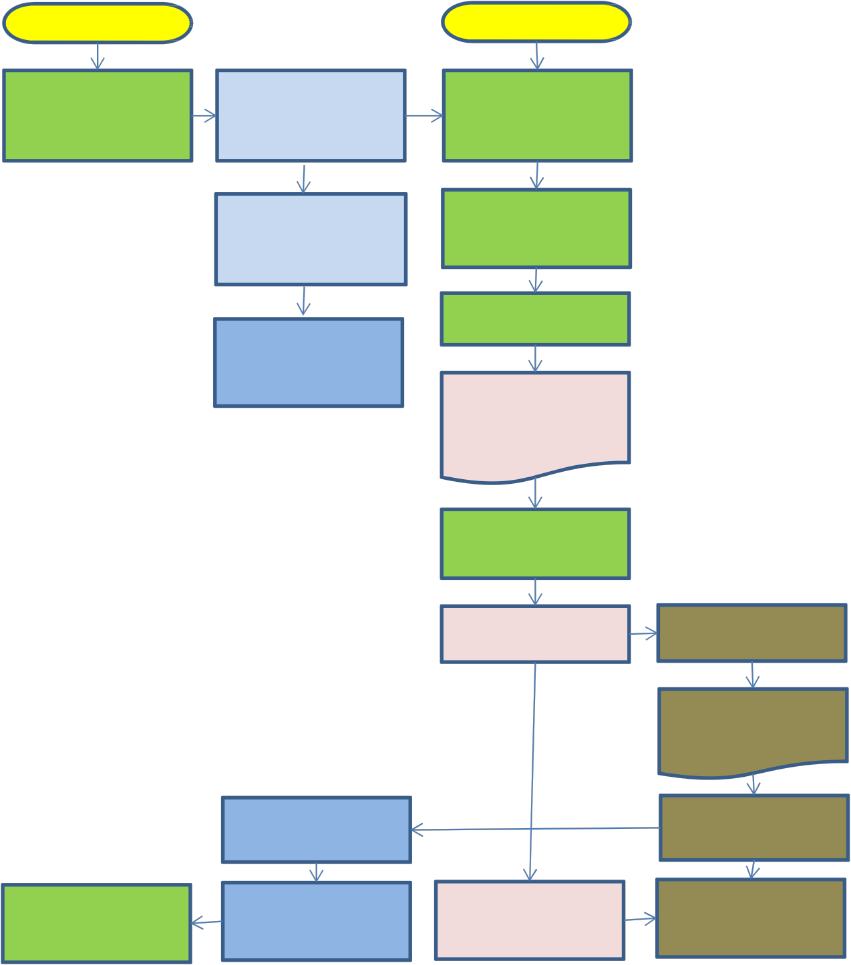

**Applicant AREC Supplier ALEA**

Begin Begin

Applicant accesses

AREC Web site

Link on AREC Web site takes Applicant to Supplier Web site

Applicant registers and enters personal data on Supplier Web site

Link on AREC Web site takes Applicant to License Application

Applicant selects FP scan location on Supplier Web site

AREC processes application, pending receipt of rap sheet

Applicant pays FP

fees to Supplier

Supplier system produces instruction sheet for printing by Applicant

Applicant goes to selected FP scan location

Supplier scans FP and transmits to ALEA

ALEA receives FP and

Data

Search is performed in FBI IAFIS and ALEA AFIS systems

AREC processes rap sheets

Results are transmitted to AREC

Applicant receives license decision from AREC

AREC determines whether to issue license

Supplier pays ALEA for

ALEA and FBI fees

ALEA reconciles Fees to

Transactions